**LAB 03: Use case description**

Use cases can be written in different formats and levels of formality:

1. **Brief**

Write one-paragraph summary, usually of the main success scenario.

**When?**

It is done during early requirements analysis, to get a quick sense of subject and scope. It May take only a few minutes to create.

**Example**

(**Process my Email**): A student can login, see the headers of Email messages and then read, delete, reply to, and forward a message.

1. **Casual**

It is Informal paragraph format. Multiple paragraphs that cover various scenarios

**When?**

As stated above.

| **Name** | **short name** |
| --- | --- |
| (**Main Success Scenario**): | one paragraph. |
| (**Alternative scenario 1**): | if .... one paragraph |
| (**Alternative scenario 2**): | if .... one paragraph |

**Example**

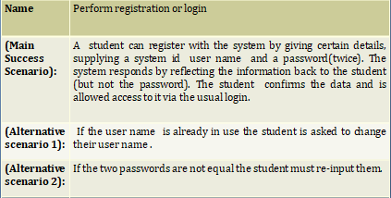

1. **Fully dressed**

**When?**

After many use cases have been identified and written in a brief format, then during the first requirements workshop a few (such as 10%) of the architecturally significant and high-value use cases are written in detail.

Template

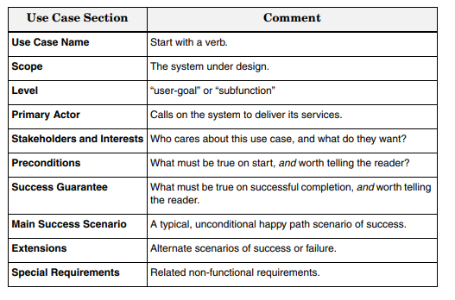

**Example**

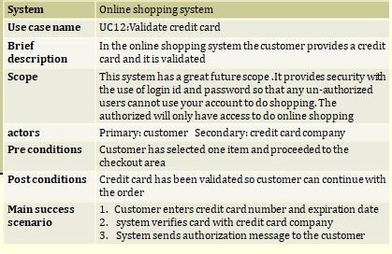

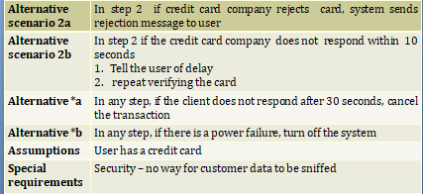

**Example: Point of sale system**

**Scope** : Next Gen POS application

**Primary Actor** : Cashier

**Stakeholders and Interests**:

– **Cashier:** Wants accurate, fast entry, and no payment errors,

– **Salesperson**: Wants sales commissions updated.

– **Customer**: Wants purchase and fast service with minimal effort. Wants easily visible

display of entered items and prices. Wants proof of purchase to support returns.

– **Company:** Wants to accurately record transactions and satisfy customer interests. Wants to ensure that Payment Authorization Service payment receivables are recorded. Wants automatic and fast update of accounting and inventory.

– **Manager:** Wants to be able to quickly perform override operations, and easily debug

Cashier problems.

– **Government Tax Agencies:** Want to collect tax from every sale.It May be multiple agencies, such as national, state, and county.

– **Payment Authorization Service**: Wants to receive digital authorization requests in the

correct format and protocol. Wants to accurately account for their payables to the store

**Preconditions**: Cashier is identified and authenticated.

**Success Guarantee or Post conditions**: Sale is saved. Tax is correctly calculated. Accounting and Inventory are updated. Commissions recorded. Receipt is generated. Payment authorization approvals are recorded.

**Main Success Scenario (or Basic Flow):**

1. Customer arrives at POS checkout with goods and/or services to purchase.

2. Cashier starts a new sale.

3. Cashier enters item identifier.

4. System records sale line item and presents item description, price,

Cashier repeats steps 3-4 until indicates done.

5. System presents total with taxes calculated.

6. Cashier tells Customer the total, and asks for payment.

7. Customer pays and System handles payment.

8. System logs completed sale and sends sale and payment information to the external Accounting system (for accounting and commissions) and Inventory system (to update inventory).

9. System presents receipt

10. Customer leaves with receipt and goods (if any).

**Extensions (or Alternative Flows):**

*a. At any time, Manager requests an override operation:

1. System enters Manager-authorized mode

2. Manager or Cashier performs one Manager-mode operation. e.g., cash balance change, resume a suspended sale on another register, void a sale, etc.

3. System reverts to Cashier-authorized mode.

*b. At any time, System fails:

To support recovery and correct accounting, ensure all transaction sensitive state and events can be recovered from any step of the scenario.

1. Cashier needs to restarts System, logs in, and requests recovery of prior state.

2. System reconstructs prior state.

2a. System detects anomalies preventing recovery:

1. System signals error to the Cashier, records the error, and enters a clean state.

2. Cashier starts a new sale.

1a. Customer or Manager indicate to resume a suspended sale.

1. Cashier performs resume operation, and enters the ID to retrieve the sale.

2. System displays the state of the resumed sale, with subtotal.

2a. Sale not found.

1. System signals error to the Cashier.

2. Cashier probably starts new sale and re-enters all items.

3. Cashier continues with sale (probably entering more items or handling payment)

2-4a. Customer tells Cashier they have a tax-exempt status (e.g., seniors, native peo-ples)

1. Cashier verifies, and then enters tax-exempt status code.

2. System records status (which it will use during tax calculations)

3a. Invalid item ID (not found in system):

1. System signals error and rejects entry.

2. Cashier responds to the error:

2a. There is a human-readable item ID (e.g., a numeric UPC):

1. Cashier manually enters the item ID.

2. System displays description and price.

2a. Invalid item ID: System signals error. Cashier tries alternate method.

2b. There is no item ID, but there is a price on the tag:1. Cashier asks Manager to perform an override operation.

Study remaining fully dressed from following link

<https://studylib.net/doc/8248662/use-cases---craig-larman>

**Two column format in use case diagram**

Use case description involves these main components:

1. Use Case Number | Use Case Name
2. Actor involve
3. Goal of the use case
4. Pre-requisite of the use case
5. Description of use case which includes user action and system response
6. Alternate scenario of the use case

Let’s consider an example of ATM machine for elaborate the use case description.

For an ATM machine scenario these use cases are involved:

* + Validate PIN
  + Withdrawal | Transaction
  + Deposit
  + Check Balance

| **UC-01** | **Validate PIN** | |
| --- | --- | --- |
| **Actor** | Customer | |
| **Goal** | Verify PIN number | |
| **Pre-requisite** | User must have a valid PIN code | |
| **Description** | **User Action** | **System Response** |
| * User enters their card * User Enter a valid PIN number | * System accepts card and ask for PIN * Verify entered PIN number |
| **Alternate** | * If a user enters wrong PIN, then re-enter PIN code * If a user enters wrong PIN for 3times, then card is blocked | |

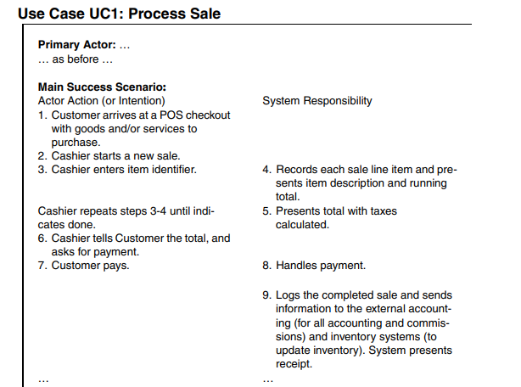

**LAB TASKS**

**Q1. Consider following scenario and identify at least 5 use cases . Among 5 use cases two of the use cases should be described by using the fully-dressed format and the casual format can be used for the rest of the use cases**

**Online Bookstore System on a Cloud Platform**

This project aims to develop an online bookstore system that acts as a central database containing various books in stock along with their title, author's name, published date, and cost. This project, basically a website, will get a large amount of online visitors. The system should be hosted on a cloud platform in order to avoid site crash. The project can be developed using Java (front end support) and SQL (back end support). The online bookstore stores various book related details. Microsoft Azure can be used for cloud based infrastructure. The user will be able to login, View a wide range of books arranged in respective categories, Select desired book and view its price, Check the availability of the book, Search for specific books on the website, reserve a book by filling-in a form, See the due date (25 days from the date of issuance.),Get a reminder once they cross the due date of submission of a book.

**Q2 Consider an automated student registration system which requires student to login as well as provides registration to students. It also enables student to enroll in courses. The student can enroll in only those classes that are part of their degree fully dressed use case in two column format for following use case** “Enroll in a course”